Slido Evaluation

September 17, 2025

**SHIP Partner Meeting**

**Office of Performance Improvement and Accreditation (OPIA)**

Contents

Slido overview 3

Q1: How satisfied are you with the progress made on the access to care goals in the first year of the five-year plan? 4

Q1b: Please describe why you selected your satisfaction level for access to care? 5

Q2: Now that you've seen the progress made towards these goals, do you have any suggestions or thoughts for the Mental Health team? 7

Q3: How satisfied are you with the progress made on the smoking/vaping/tobacco goals in the first year of the five-year plan? 8

Q3b: Please describe why you selected your satisfaction level for smoking/vaping/tobacco? 9

Q4: How satisfied are you with the progress made on the nutrition goals in the first year of the five-year plan? 10

Q4b: Please describe why you selected your satisfaction level for nutrition? 11

Q5. How satisfied are you with the progress made on the drug use goals in the first year of the five-year plan? 12

Q5b. Please describe why you selected your satisfaction level for drug use? 13

# Slido overview

# Q1: How satisfied are you with the progress made on the access to care goals in the first year of the five-year plan?

# Q1b: Please describe why you selected your satisfaction level for access to care?

"Great work in the area, especially considering the difficulty of policy creation. Appreciate the teamwork from KY DPH to increase the participation in NHSC and the Kentucky Office of Rural Health administered KY loan repayment programs. While we do have a federal delay in the program, we hope to continue to show this increase over the coming years."

"Change takes time and it sounds like a lot has been accomplished so far."

"Do not feel like we are meeting enough to make adequate progress."

"There is much to do, and the group is working on some of those. Tough area to work on."

"At least one access to care component was fulfilled successfully!"

"This definition of “access” and focus does not take into account communication access, language access, or the needs of persons with disabilities or non-preferred English users and their access to existing services."

"They appear to be navigating the new playing field well!"

"A lot of work has been done to identify barriers."

"This is a difficult task and progress impressive."

"Appreciate all hard work"

"The focus has been on highly needed areas"

"Individual in urban areas still face challenges to quality access to care. Trying to get scheduled for an appointment and the nearest availability is in 2026"

"I feel a little frustrated for them because so much of it depends on legislature."

"I love seeing progress being made. Especially goal is being exceeded. We still have work to do, but it looks like we’re moving in the right direction."

"Don't know enough about the project"

"Solid progress on workforce development"

"Progress was made despite challenges and limitations in the year"

"Great Progress!"

"Policy changes take time"

"I think a lot of work has been done and the barriers are beyond some control"

"There is great progress being made despite the challenges faced recently."

"I am new to this so selected neutral until I have further information. Thanks!"

"Appreciate the committee looking at all available avenues and building on what has been accomplished in the past."

"Small clear steps forward"

"There is clarity around the specific challenges--a key first step!"

"It is hard to capture wins in this space and they did it. They clearly have true ownership and expertise in this area and they are doing great work! "

"Nice progress!"

"Progress made within the first year with more progress possible"

"Met the goal."

"Good direction"

"Great to see progress made!"

"Not familiar with goals"

"The group has made great progress."

"Exceeded goals and strong plan for next steps"

"Progress is made and it’s such an important area."

"Impressive progress!"

"A diverse selection of approaches with good results"

"There is still more work to be done."

"Amazing to hear they’ve already met some of their goals"

"Not familiar enough with the goals vs. results"

"Always more to do!"

"Policy change mechanisms that are being explored"

"Excellent work despite all the federal challenges"

"Progress has been made even though goes weren't all met."

"I think they’ve made good progress!"

"I believe that any progress during the first year is remarkable!"

# Q2: Now that you've seen the progress made towards these goals, do you have any suggestions or thoughts for the Mental Health team?

"Love to see the inclusion of persons with disabilities including children and their families."

"Perhaps connecting with Kynect Resources would be a good move? They are working to create a network of resources gathered in an easy to search network for providers and individuals. Savannah Sublette-Federico is the Executive Advisor of Kynect Resources."

"Great job!"

"Public health could work to address not only the behavioral health of our communities, but also of our own and other workforces."

"Have you looked at Credible Mind as a potential resource for the web content?"

"Check out Get Moving Whitley!"

"great job, lots of participation and you can always use more partners-"

"Partner with KHDA"

"If you need FRYSC contacts in Shelby, Henry, Oldham, Owen, Trimble, Gallatin, and Carroll let me know. Many coordinators have/collaborate in after school programming- Melanie Madison"

"There seems to be a fair amount of duplication with other resources. Resource sheets become outdated almost immediately and are difficult to maintain."

"A comprehensive survey of current local health dept activity in this area would help you not recreate the wheel"

"Great initiatives and progress!"

"Have you all been in contact with Kentucky State Police regarding their Handle with Care program with schools?"

"The selected strategies were appropriate and well developed"

"What about CredibleMind as a resource. NACCHO has really been working closely with that as a resource"

"Good stuff!"

"I appreciate the recognition between physical activity and decreased anxiety/depression."

"Great to see the progress made!"

"Please continue to look at emerging challenges for children and young people. The need is great!"

"Love the use of the toolkit from KY River"

"Such an important topic. Good to see collaboration between BHDID and DPH"

"Great progress!"

"Impressive progress so far."

"Keep up the good work!"

# Q3: How satisfied are you with the progress made on the smoking/vaping/tobacco goals in the first year of the five-year plan?

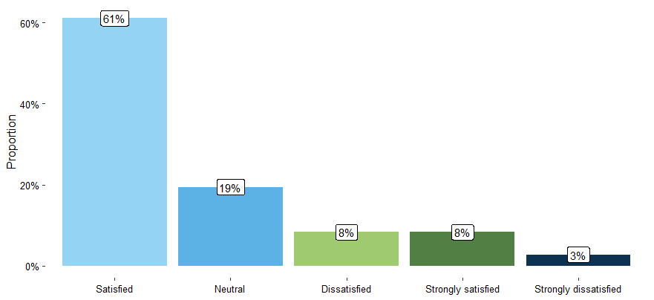

# Q3b: Please describe why you selected your satisfaction level for smoking/vaping/tobacco?

"Challenging, but going in the right direction"

"With the all the challenges, the progress is amazing!!"

"Pivoting skills are top notch!"

"Clearly Working to make progress and redefine goals and objectives under significant funding constraints."

"They've done a terrific job \"keeping the faith\" and remaining flexible. Let's keep moving forward!"

"So many challenges, keep up the good work."

"A lot of work has been completed with such a decrease in staffing and the needs have been identified."

"Great work considering the absurd budget cut"

"I think...all things considered...they have done great work with what they have available"

"A lot of changes and I appreciate the way the goals have adjusted, but are still in place"

"Satisfied because given the challenges , I think maintaining current progress is key "

"Seems like the group is on track"

"With so many barriers, progress of any kind is remarkable."

"I'm satisfied with the way the team has been able to pivot. I know a lot of the goals have changed to basic survival mode- but that is what Kentucky needs to do right now! So great job shifting and remaining focused"

"So many challenges! I appreciate how this group is pivoting and adapting. Great leadership 🙌"

"The appear to be trying to keep the program as sustainable as possible with all of the major cuts"

"I said strongly dissatisfied but they’ve done the best they can with an impossible and unthinkable situation re: lack of investment"

"Keep up the good work!"

"Great work in the middle of shifting sand!"

# Q4: How satisfied are you with the progress made on the nutrition goals in the first year of the five-year plan?

# Q4b: Please describe why you selected your satisfaction level for nutrition?

"We were aligned and experienced similar success in our community"

"I would love to know plans on expansion for food prescription programs- and if we know of clinics who would like to get involved, how do we sign up?"

"They seem to have a good handle on the landscape of nutrition programs. I am excited for the Nutrition and Mental Health collab with Our Healthy KY Home. +++ to the comment about the intersection of physical wellbeing and mental health. And it is very difficult to be mentally healthy when you are experiencing food insecurity- so our nutrition programs play a big role in our behavioral health needs for the state. Excited for our collaboration!"

"Nutrition is so foundational not only to health, but to life, that it is easy to take for granted this critical work. Thank you for all you are doing!"

"Sounds like progress has been made despite obstacles"

"What were the results of the pilot project in Allen County? I"

"As we have previously heard, many obstacles, but progress has been made for Wellness and Food."

"Everything sounds like it is on track"

# Q5. How satisfied are you with the progress made on the drug use goals in the first year of the five-year plan?

# Q5b. Please describe why you selected your satisfaction level for drug use?

"Great teamwork among our community partners and surrounding counties, led to great success with RCC certification in our Tristate area and combined efforts for the well-being of our community members. Great collaboration, supporting the great work"

"It does sound like work is continuing despite barriers"

"Several areas have already surpassed their goals, and others are well on the way to being achieved by the projected date. Good work!"

"I feel their focus and targets are spot on, and the progress they’ve already experienced is wonderful!"

"Can see progress taking place!"

"Since you all have accomplished so much, once all the baselines are identified raise your targets. The sky is the limit!Great focus on EBPH and evaluation."

"Overshooting your goals is amazing."

"Have exceeded year 1 benchmarks in many areas."

"It looks like we may have to update some of these goals for the next four years! "

"great work!"

"I appreciate the focus on data-driven decision making"

"The numbers are very impressive!"

"You've knocked it out of the park! The ball was last seen leaving town! Keep up the great work!"